## horizontal line



Project Name:- File structure implementation using Btree

**Submitted to:- MR.NITIN GUPTA**

**Shivek Soni Shubhiv Dogra Akshay Thakur**

[**Shivek6856@gmail.com**](mailto:Shivek6856@gmail.com) **shubhiv829@gmail.com akshay8351806@gmail.com**

**91-9413752688 91-7018272603 91-8219281759**

# Overview

In this project we have implemented a file structure by using a B-Tree in which we have used different classes to merge the functions.

Here are the screenshots of the output

1. INSERTION

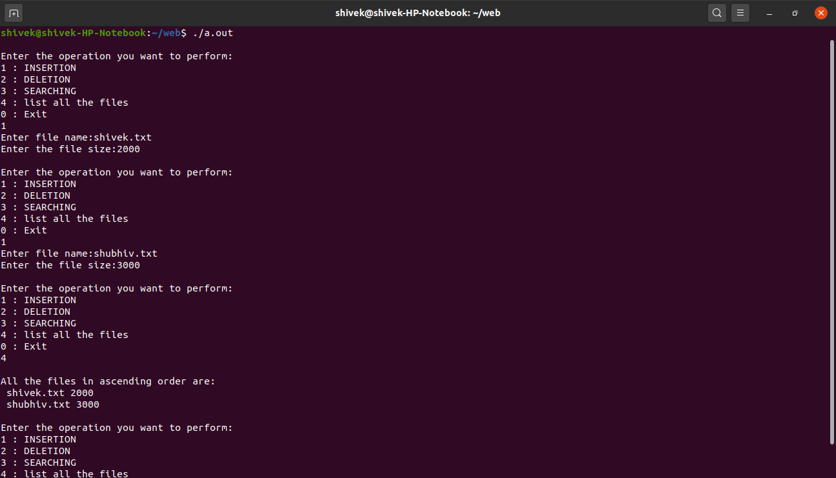

1. DELETION

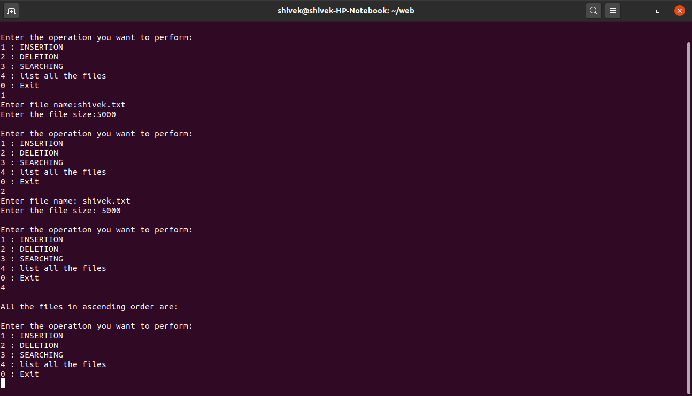

1. SEARCHING

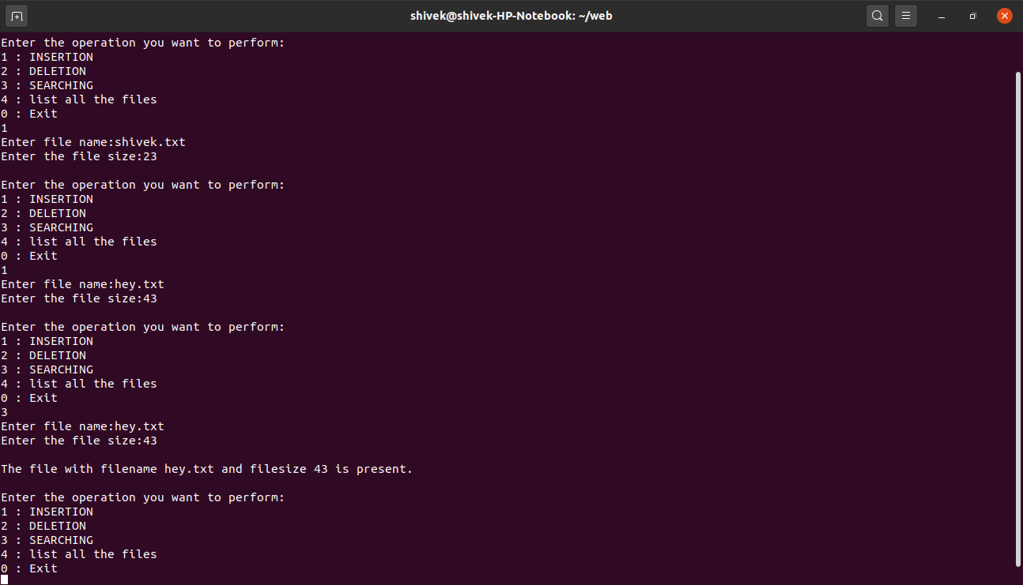

1. LIST OF THE FILES

